Task 3:
Lost Data Recovery.

Tool Used:
- Recuva
Steps of procedure:
- Lauch the recuva tool.
- Select the affected drive.
- Chose scan mode.
        - Quick scan is for recent deletions
        - Deep scan for formatted drives
      - A list of deleted files appears.
      - Select the file you want to recover and click on recover and thats done.

Task 4:
Credit card fraud detection.

Code:
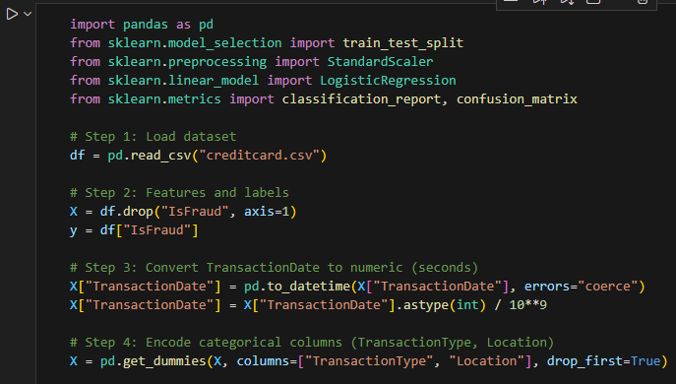
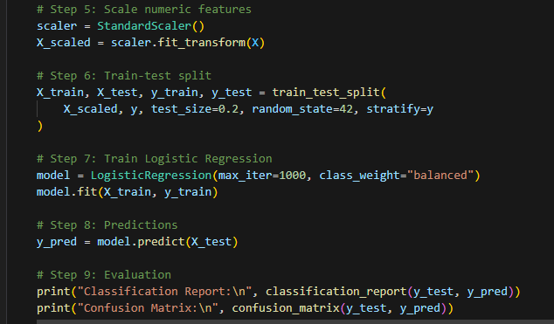

Output:
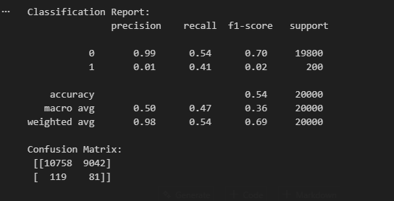

This is simple version of credit card fraud detection.

